Notes and Documentation for TraloCoil Mark I

1. This document serves as a record of the build process of the Audio Modulated SSTC, as well as an explanation of the physics behind the phenomenon.
2. Design of the basic logic drivers and overall board layout geometry based heavily on the oneTesla v1.1 board.
3. Logic drivers isolated from the power section using separate power planes.
4. Ripple noise from V+ and V- power rails don’t pose a significant enough noise threat to the logic processing – feedback signal strong enough to overcome any level of noise. Furthermore, large bus capacitors serving as a voltage doubler helps stabilize signal and filter out noise.
5. Primary inductor current feedback topology used in oneTesla replaced with cruder, yet necessary antenna feedback due to lack of primary-secondary circuit resonant effects.
6. Far extension of antenna necessary to capture sufficient EM waves for the feedback loop to kick in.
7. Basic operational function of the Tesla Coil detailed below (taken from academic report written for class) :

***Section 1 – Spark Gap Tesla Coil Theory of Operation***

The original 19th Century Spark-Gap Tesla Coil forms the foundation of the newer generation models.

Fig. 1 shows the schematic of such a Tesla Coil.

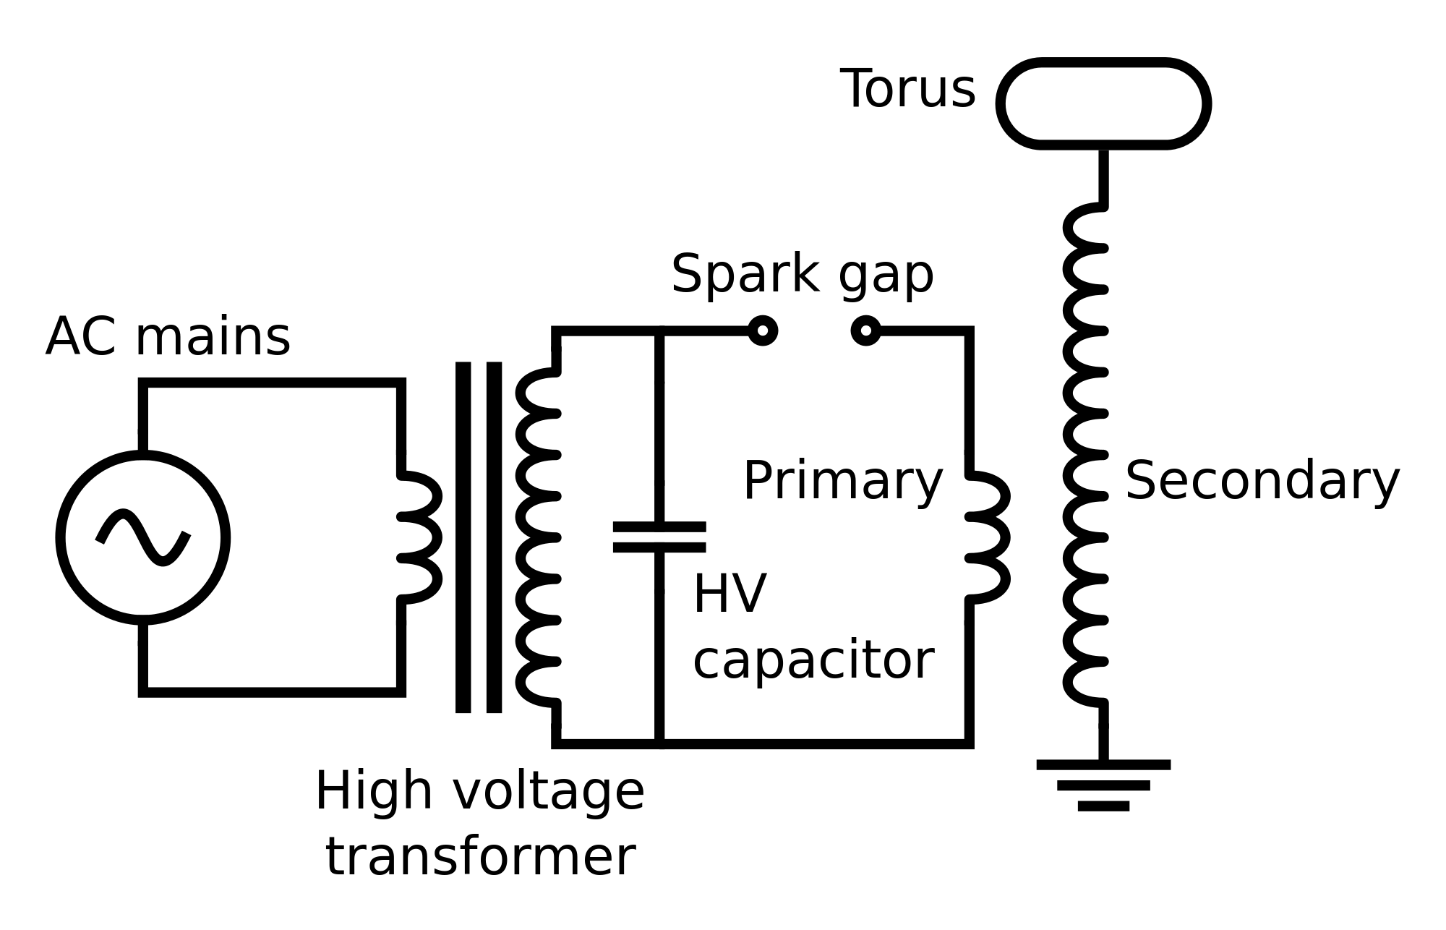

Fig. 1. Spark Gap Tesla Coil Schematic.

Tesla’s original model consisted of four primary components.

1. The power source.
2. The spark gap.
3. The Primary Resonator.
4. The Secondary Resonator.

As seen in the schematic above, the power source is typically a high voltage transformer connected to AC mains. The spark gap is exact what it sounds like.[1] The Primary Resonator is made up of the LC circuit directly connected to the spark gap. The Secondary Resonator Is made up of the larger inductor, connected to the torus, which forms a capacitor with ground. Thus, a second LC circuit is created.

Basic operation of the Tesla Coil occurs in two distinct stages – the **charging** stage and the **resonant** stage.

During the charging stage, the AC mains power source, fed through the high voltage transformer, charges the primary capacitor during the positive ac half cycle until it reaches the “breakdown voltage” inherent to each spark gap.

Once this breakdown voltage is reached, the spark gap acts essentially as a short circuit, reaching the resonant phase. This effectively isolates the high voltage transformer from the LC primary circuit closed by the gap. At this point, the charged capacitor discharges into the primary inductor, and a damped oscillation begins. It is here that the bulk of the interesting effects occur.

Fig. 2. Shows a simplified version of the decay.

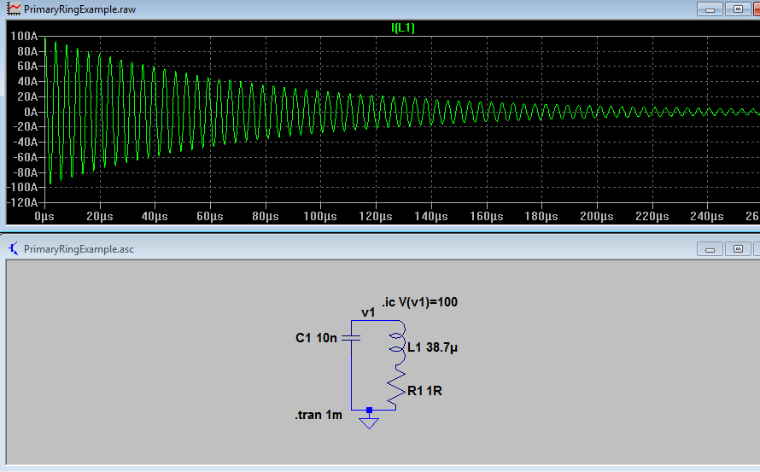

Fig. 2. Damped Ringing Oscillation.

It is important to note at this point that the spark gap stays unquenched, despite its voltage reaching zero during each oscillation cycle. However, the gap does act as a variable resistive element, allowing for the oscillations in the tank circuit to die down eventually.

However, as the primary and secondary inductor are coupled to each other, the primary inductor current induces a voltage equivalent to

$V_{secondary} = M_{L1,L2}\frac{dI_{primary}}{dt}$

Where M is the mutual inductance of the two inductors.

By doing this, the secondary circuit is driven at the resonant frequency of the primary, causing a massive voltage buildup – both from the transformer action caused by M, as well as the fact that driving a resonant load at ωres causes a massive voltage buildup.

Typically, in these coupled circuits, if perfect coupling occurs, the secondary and primary voltages would simply be scaled up versions of each other, as seen in Fig. 3.

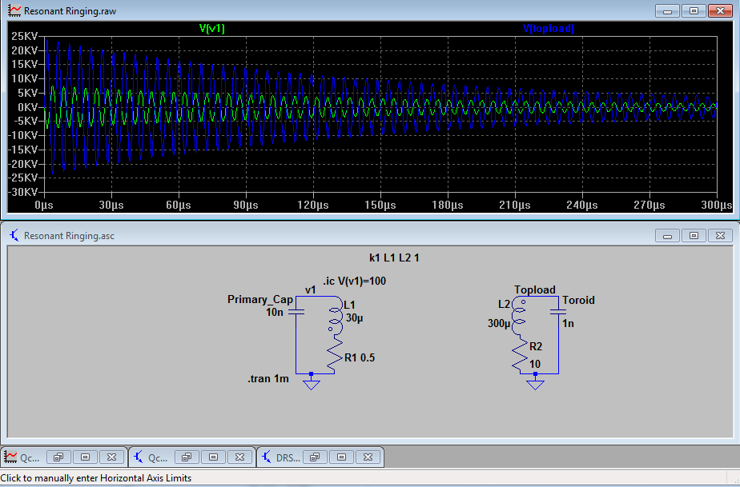

Fig. 3. Ideally coupled resonators.

However, if coupling is sufficiently low, as is in the case of any Tesla Coil, the energy transfer is not ideal, and the waveforms shift out of phase with each other, as shown in Fig. 4.

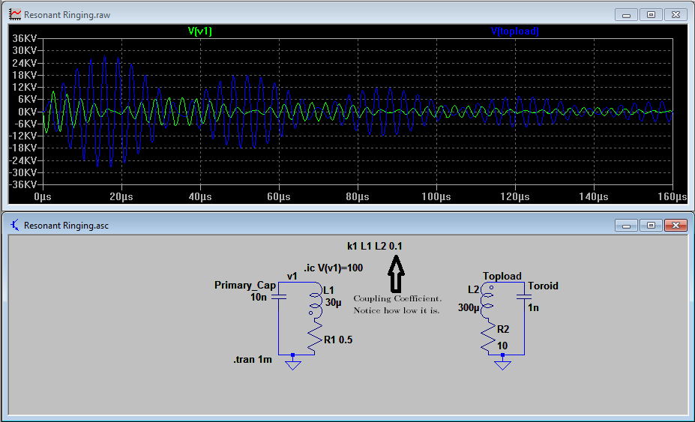

Fig. 4 Resonant Ringing.

Because the energy going into each “bump” following the first is necessarily not as powerful due to resistive losses, an effort has been made, by increasing spark gap timing and efficiency, to halt the ringing process at the first primary (green) node. This restarts the charging step in the primary, isolating the transferred energy in the secondary, and allowing that to ring down naturally, its energy being dispersed through resistive losses (the spark itself!)

Overall, the second phase of the SGTC operation can be summarized with two coupled integrodifferential equations.

$$(2) L_{p}\frac{di_{p}}{dt} + R_{1}i_{p} + \frac{1}{C_{p}}\int{i_{p}dt} = V_{input} + M\frac{di_{sec}}{dt}$$

$$(3) L_{sec}\frac{di_{sec}}{dt} + R_{2}i_{sec} + \frac{1}{C_{sec}}\int{i_{sec}dt} = M\frac{di_{p}}{dt}$$

From this, we can construct a block diagram representation of the overall transfer function from input voltage to primary current.

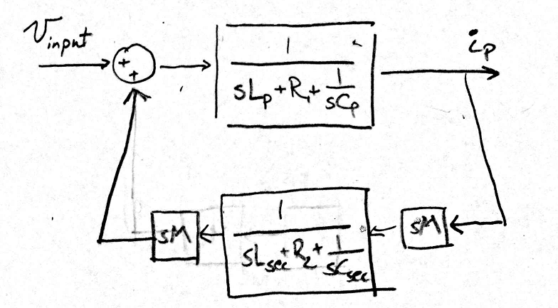

Fig. 4. Primary Resonator Block Diagram

This, in turn, allows one to derive the overall (disgustingly complicated) transfer function of Vinput/Iprimary , which will come in handy later.[2]

However, such a process gets increasingly more complicated. The beauty behind Tesla’s original design is its pure simplicity. No need for complicated circuitry – the resonant nature of its two circuits does all of the work for you. The drawback here being threefold.

1. The spark gap is inherently lossy, and its existence requires the presence of a high-voltage transformer. Those things hare HEAVY. (And probably dangerous.)
2. The natural step response of the primary is the driving force behind the resonant rise. We have very little control over the response.
3. Spark gap adjustment involves motor control and timing for best results.

As such, efforts were taken to find a viable alternative to the SGTC.

***Section 2 – Intermediary Versions***

Decades after Tesla’s discovery, the first real new innovation in the field of Tesla Coils was the Vacuum Tube Tesla Coil. Unlike its Spark Gap counterpart, the VTTC used a vacuum tube to switch the oscillating current between the two LC circuits.

Pictured below is the most basic form of VTTC.

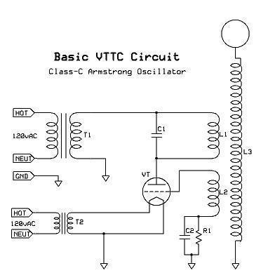

Fig. 5. Basic VTTC circuit. All credit to Steve Ward.

The VTTC is the first example of the resonant circuitry being driven by some sort of switching feedback instead of just the primary and secondary ringing effect. Without going into much detail, the VTTC works by a basic feedback network. L3 is driven by L1’s mutual inductance each cycle, but since L3 and L2 are also coupled, each pulse from L1 affects L2 to an extent. L2 then either powers or depowers the Vacuum Tube grid (analog of the base/gate of a transistor), and causes the primary LC to oscillate at the “locked-on” resonant frequency of the secondary circuit.

However, this circuit, as did the SGTC, had many drawbacks – the foremost of which was that it required two transformers to operate properly. One to provide the tank voltage, and one to provide the gate bias voltage. This problem is only exacerbated by the fact that certain vacuum tubes are quite particular about the choice of gate voltage. Parts are therefore difficult to find.

Finally, in the Early 2000’s a breakthrough was made, and the first Solid State Tesla Coil came into existence. This particular device differed from its forebears by altogether eliminating one of the LC circuits, preferring to drive the secondary LC with only a single L.

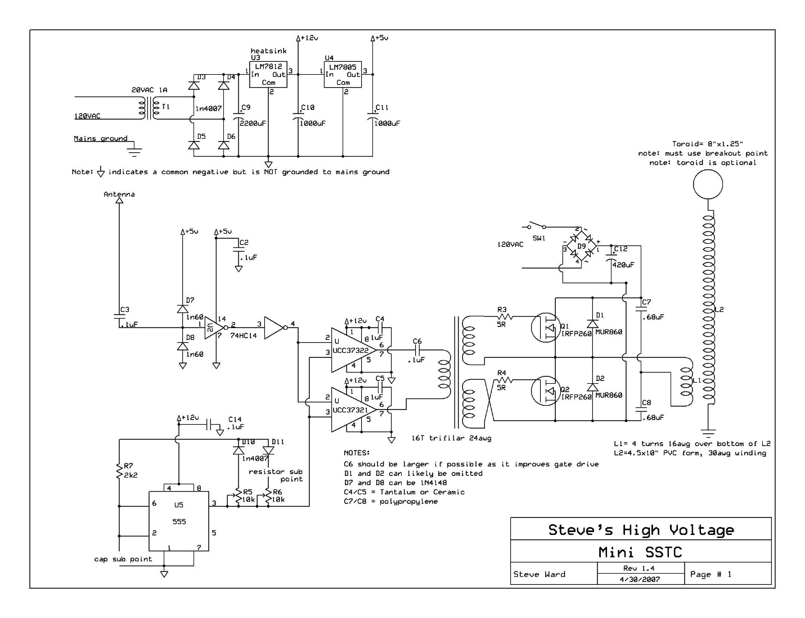

Fig. 6. The Quintessential SSTC.

The above shows a rather old, but simple version of the original Solid State Tesla Coil. The two important parts to note are the bridge that drives the primary inductor L1 as well as the antenna on the far left of the schematic.

The feedback scheme used there involves the antenna sensing the fluctuating EM field produced by the secondary during its ringing. That frequency is then used to produce a logic level signal that drove a half-bridge of MOSFETs (shown by Q1 and Q2) that alternated current through the primary inductor at the resonant frequency.

(Much of the technology used for the Solid State Coil was adapted for use in the Dual-Resonant topology that oneTesla is based on, thus the similarities in schematic.)

Despite this design being significantly more efficient in terms of material cost and clunkiness, the original Solid State Coil suffered from a major drawback of its own. Its spark length and scalability left much to be desired. The lack of a primary LC circuit not only prevented the resonant rise effect from happening at the primary, but it was also harmful to the transistors themselves.

Because the primary circuit didn’t have a resonant frequency to run at, every time the transistors switched, the current waveform through the inductor didn’t match the resonant switching frequency. As such, the transistors were forced to “hard-switch,” or turn off and on regardless of the current. As such, the transistors themselves had to be hardy, or they wouldn’t survive the thousands of hard-switching cycles per second. This also had the secondary effect of preventing any appreciable level of upward scaling. Once the currents got too high, the transistors would simply short through and die.

1. Additional notes about spark gap behavior can be found in Appendix B.
2. Derivation in Appendix A.